Introduction
In today’s blog post, we’ll explore how to enhance your Power BI reports by dynamically disable slicers in Power BI based on other slicer selections. This functionality can significantly improve user experience by guiding them through data exploration in a logical and interactive way.

Understanding the Need for Disabling Slicers
Why Disable Slicers in Power BI?
The primary goal is to prevent users from making conflicting selections, which can complicate data analysis. For instance, if a user selects a specific period, such as the last 3, 6, or 12 months, it’s logical to disable the Date Range slicer to streamline the data visualization process.

Step-by-Step Guide to Disabling Slicers

Step 1: Setting Up the Measure
First, we need to create a new measure that checks if the Period slicer is filtered. Let’s call this measure Timeline Slicer Disable. The DAX formula for this measure would look something like this:

Timeline Slicer Disable = IF(ISFILTERED(Periods[Custom Period]), 1, 0)

Here, Periods[Custom Period] refers to the column used in your Period slicer. This measure returns 1 when the slicer is filtered and 0 otherwise.
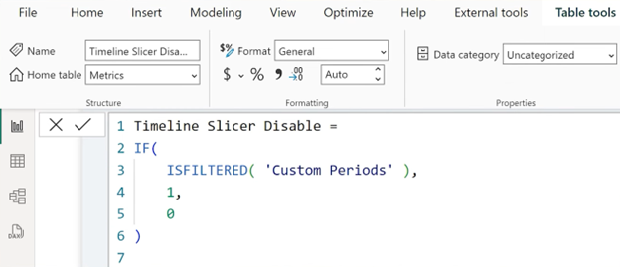

Step 2: Applying the Measure as a Visual Filter
Now, let’s use this measure to control the visibility of the Timeline slicer:
- Select the Timeline slicer.
- Navigate to the filters pane.
- Drag the Timeline Slicer Disable measure onto the “Filters on this visual” section.
- Set the filter to show items when the measure equals 0.
When the Period slicer is used, the Timeline slicer will be disabled (i.e., hidden), signaling to the user that they cannot specify a date range.

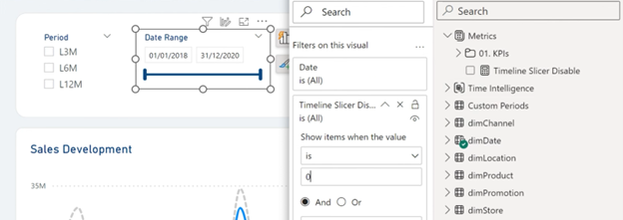

Step 3: Enhancing User Feedback
To make the interface more intuitive, consider modifying the header text of the Timeline slicer based on its active status:
- Create another measure for conditional formatting of the slicer header:

CF Text Timeline = IF([Timeline Slicer Disable] = 1, “Deselect Period First”, “Date Range”)

2. Go to the slicer’s formatting options, select the header, and apply the CF Text Timeline measure to dynamically change the header text.
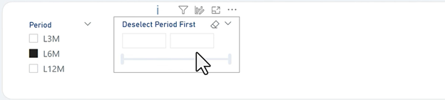

Step 4: Adjusting the Slicer’s Appearance
To further clarify the disabled state of the slicer, you can change the color of the header text:
- Create a measure to return the appropriate color:

CF Color Timeline = IF([Timeline Slicer Disable] = 1, “#CCCCCC”, “#0000FF”) // Light grey when disabled, blue otherwise.

- Apply this measure in the slicer’s formatting settings under the “Font color” option.

Extending the Functionality to Other Slicers in Power BI
The technique of dynamically disabling slicers based on selections can be highly beneficial in various scenarios beyond just date and period slicers. By applying similar logic to different types of slicers, you can enhance the interactivity and usability of your Power BI reports. Here, we delve into how this approach can be used with other slicer types, such as those filtering by store location or promotion type.

Scenario: Store Location and Promotion Type Slicers
Imagine a scenario where your report includes data from multiple store locations, and some stores participate in specific promotions while others do not. By dynamically disabling the Promotions slicer when a non-participating store is selected, you can prevent user confusion and ensure data integrity.

Implementation Steps

Step 1: Creating the Measure
To start, you need to create a measure to check whether the selected store participates in any promotions. This measure can look something like this:

Promotion Slicer Disable = IF(SELECTEDVALUE(Stores[Store Name]) = “Catalog Store”, 1, 0)

This measure checks if the selected store is “Catalog Store,” which we assume does not participate in promotions, and returns 1 (true) if so.

Step 2: Applying the Measure as a Filter
Use this measure to control the visibility of the Promotions slicer:
- Select the Promotions slicer.
- Go to the filters pane.
- Drag the Promotion Slicer Disable measure onto the “Filters on this visual” section.
- Configure the filter to disable the slicer (i.e., hide or deactivate it) when the measure equals 1.

Step 3: Conditional Formatting for User Feedback
To improve user experience:
- Create another measure to provide feedback on why the slicer is disabled:

CF Text Promotion = IF([Promotion Slicer Disable] = 1, “Promotions Not Available”, “Select a Promotion”)

- Apply this measure to the header of the Promotions slicer using the formatting options to change the header text dynamically.

Step 4: Adjusting Visual Cues
Adjust the color or style of the slicer when disabled to make it visually apparent:
- Create a measure to define the color based on the slicer’s status:

CF Color Promotion = IF([Promotion Slicer Disable] = 1, “#CCCCCC”, “#0000FF”) // Light grey when disabled, blue otherwise.

2. Implement this color change in the slicer’s formatting settings for the header font color.

Broadening the Approach
This method can be extended to various other scenarios, such as:
- Product and Category Slicers: Disable product slicers when a specific category that does not include any products is selected.
- Geographic Slicers: In cases where certain reports or data apply only to specific geographic locations, you could disable city or region slicers based on the selection of a particular country or state.
- Time-sensitive Slicers: Disable slicers related to time periods if a real-time data feed is selected that does not encompass historical data.

Benefits of Disable Slicers in Power BI
By applying dynamic slicer disabling across different scenarios, you can:
- Enhance User Experience: Make your reports more intuitive and easier to navigate.
- Prevent Data Confusion: Avoid presenting users with options that are irrelevant or invalid based on their prior selections.
- Improve Report Performance: Reduce unnecessary calculations and data loading for conditions that are not applicable.

